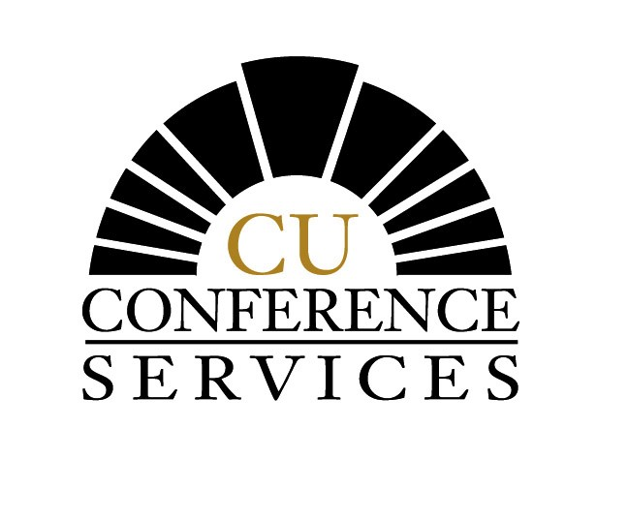
University of Colorado at Boulder USNCTAM Campus Housing Reservation Form
CU Conference Services Telephone: (303) 492-5151 Fax: (303) 492-5959

(Please Type or Print Clearly)
Name of Conference: 15th U.S. National Congress on Theoretical and Applied Mechanics

Participant’s Name: / / Gender: F M
Last First Initial

Address: Country:

/ /
City State Postal Code

Daytime Telephone: ( ) Fax: ( )

E-mail Address:

Arrival Date: Departure Date:

Fees below include 5 nights lodging and 5 breakfasts. Please request one of the following:
*Single (1 person per room) - $345.79 per person (Includes all applicable taxes and charges)
*Double Room (2 per room; price is per person) - $202.47 per person
(Includes all applicable taxes and charges)

(Roommate preference name, if any)

*Tax subject to change

*There are a limited number of single rooms. If unavailable, would you be willing to share a double room with another conference participant. □ YES □ NO

Special Needs:

Complete if accompanied by spouse and/or family member:

Spouse’s Name: Arrival Date: Departure Date:

Child : Arrival Date: Departure Date:
Name Age Sex

Payment is due at check-in (Check-in is available 24 hours a day). Cash, traveler’s checks, personal checks, VISA, MasterCard, American Express, Diners Card, and Discovery Card will be accepted. Checks must be in U.S. Dollars drawn from a U.S. Bank. Please do not send payment (money) in advance.
Office Use:
Confirmation Date:
_______________
Initial:_________

Mail form to: CU Conference Services
500 30th Street
Boulder, CO 80310

Fax form to: (303) 492-5959

E-mail form to: confreg@housing.colorado.edu

I understand that full payment for lodging will be expected at time of check-in. Once I have paid, and checked in with the housing front desk, I understand there will be no refunds granted if I decide to leave early for any reason.

Signature Date

Electronic submission of this form serves as your signature acknowledging acceptance of our no refund policy.

